A Multimodal Computational Intelligence Approach to Neurophysiological Predictors of Transcranial Direct Current Stimulation for Depression Treatment: Annual Review.
Abin Zorto Student ID: u2091940
Affiliation: University of East London March 18, 2025

Contents

Introduction 3
  - The Electroencephalogram . . . . . . . . . . . . . . . . . . . . . . . . . . 3
  - Major Depressive Disorder: Understanding and Current Treatments . . . 3
  - Transcranial Direct Current Stimulation (tDCS) as a potential novel treatment for MDD . . . . . . . . . . . . . . . . . . . . . . . . . . . . . . 3
  - Machine Learning: Applications and Future Trends . . . . . . . . . . . . 4
  - Potential Research Areas for Analyzing EEG Data with Machine learning 4
    - Significant Areas for Predicting Response to tDCS in Major Depressive Disorder . . . . . . . . . . . . . . . . . . . . . . . . . . 4
    - Predictive biomarkers to medicinal treatment . . . . . . . . . . . 5
    - Predictive EEG biomarkers to tDCS treatment . . . . . . . . . . 6

Hypotheses: 7

Methodology 7
  - Study Design . . . . . . . . . . . . . . . . . . . . . . . . . . . . . . . . . 7
  - Participants . . . . . . . . . . . . . . . . . . . . . . . . . . . . . . . . . . 7
  - Recruitment Process . . . . . . . . . . . . . . . . . . . . . . . . . . . . . 8
  - Data Collection Methods . . . . . . . . . . . . . . . . . . . . . . . . . . . 8
  - tDCS Intervention . . . . . . . . . . . . . . . . . . . . . . . . . . . . . . 8
  - EEG Dataset Acquisition and Description . . . . . . . . . . . . . . . . . 9

Summary of First AMR 9
  - Research Aim and Objectives: . . . . . . . . . . . . . . . . . . . . . . . 9

- Relevant Research 9
  - Sensitivity to Transient Neurophysiological Changes . . . . . . . . . . . . 9
  - Signal-to-Noise Ratio (SNR) and Reliability 10
  - Influence on Specific EEG Features 10
  - Computational Overhead of Reducing Window Size 10
  - Optimal Parameter Settings for Accuracy, Efficiency, and Interpretability 10
- Progress Since First AMR 11
  - Data Collection & Preprocessing 11
  - Feature Extraction & Machine Learning Models 11
- Data Analysis 11
  - Data Structure and Sample Characteristics 11
  - Signal Characteristics 12
  - Channel Correlations 12
  - Frequency Band Analysis 13
  - Statistical Analysis 15
- Updated Methodology 16
  - EEG Signal Processing Pipeline for Depression Remission Prediction 16
  - Data Loading 16
  - Signal Preprocessing 17
    - Upsampling 17
    - Filtering 17
    - Downsampling 17
  - Window Slicing 17
  - Feature Extraction 18
    - Spectral Features 18
    - Frequency Band Analysis: 18
    - Hemispheric Asymmetry: 18
    - Temporal (Statistical) Features 19
    - Entropy and Complexity Features 19
    - Connectivity Features 19
  - Model Training and Evaluation 20
    - Window-Level Classification 20
    - Patient-Level Classification 20
    - Experiment Logging and Visualization 20
  - Experimental Setup and Configuration 20
- Results 21
- Current Challenges and Proposed Resolutions 23

Introduction

The Electroencephalogram
An electroencephalogram (EEG) quantifies the cerebral electrical activity by means of electrodes positioned on the scalp EEG is extensively utilised in both clinical and scientific contexts due to its broad variety of applications. The EEG signals serve as reliable indicators of the brain’s health conditions, offering vital insights for the diagnosis of neurological disorders as well as for monitoring the level of anaesthesia during surgical procedures (Siuly et al. 2016).
EEG data is analysed using a range of mathematical tools and techniques, such as spectral analysis and wavelet transform. These techniques aid in identifying distinct patterns in EEG data (Murali & Kulish 2007). Technological improvements, such as the development of wearable EEG devices, have improved the practicality and usefulness of technology throughout time (Casson et al. 2010).The capacity to record alterations in cerebral function and composition, along with its straightforwardness and lack of invasiveness, renders it a desirable instrument in diverse medical and scientific contexts (Miranda et al. 2019).

Major Depressive Disorder: Understanding and Current Treatments
Major Depressive Disorder (MDD) is characterised by prolonged low mood, diminished interest, exhaustion, disrupted sleep patterns, and feelings of unease (ref) However, its heterogeneity, meaning it exhibits a wide range of symptom clusters, and its aetiology is not attributed to any specific assumptions. When diagnosing and treating MDD, it is essential to take into account all aspects of the condition, understanding that improvements in certain symptoms such as mood may occur before improvements in other symptoms like sleep disturbance (Kennedy 2008).
MDD has a substantial impact on the quality of life, specifically in terms of health- related aspects. The impact of treatment response on the quality of life is a growing concern in patient care (Cao et al. 2013). The current pharmacological treatments have limited effectiveness, resulting in a high occurrence of residual symptoms and side effects. This emphasises the necessity for the creation of innovative therapies and approaches (Libbrecht & Noble 2015).

Transcranial Direct Current Stimulation (tDCS) as a potential novel treatment for MDD
Transcranial direct current stimulation (tDCS) is an innovative non-pharmacological treatment that involves delivering low intensity electric currents directly to the brain through electrodes placed on the scalp. These currents have the ability to induce neuromodulatory changes in cortical activity that persist beyond the duration of the stimulation. Transcranial Direct Current Stimulation (tDCS) has undergone extensive research over the last 15 years, primarily focusing on its potential as a therapy for neuropsychiatric illnesses, namely depression (Brunoni et al. 2016).
tDCS is generally well-tolerated and regarded as safe, with minimal occurrence of adverse effects. Due to its non-invasive characteristics, it is a viable choice for various

categories of patients, including individuals with treatment-resistant depression (Loo et al. 2009). Experiments conducted by (Woodham et al. 2023) show no serious adverse events related to tDCS device usage, and no participants developing mania or hypomania. However, the active stimulation group in the study reported higher rates of skin redness, irritation, and dry skin compared to the sham group. Additionally, there were instances of skin burns reported due to inadequate moistening of the sponges, but these burns healed without developing into skin lesions. Therefore, while tDCS is generally safe, careful attention to proper device use and monitoring of adverse events is necessary for ensuring participant safety.
In the meta analysis conducted by (Mutz et al. 2019) the potential of tDCS for treating MDD is highlighted by several factors. Firstly, its efficacy, as evidenced by its superiority over sham treatments, suggests a significant therapeutic benefit. Furthermore, the cost-effectiveness oftDCS makes it an attractive option compared to more expensive treatments like transcranial magnetic stimulation TMS, Electroconvulsive Therapy(ECT), or psychotherapy. Additionally, the sensitivity analyses conducted in the study, including the exclusion of less invasive treatments like tDCS in comparison with ECT, demonstrate a careful consideration of treatment variables, reinforcing the validity of the findings. This comprehensive approach solidifies the role of tDCS as a promising treatment modality for MDD

Machine Learning: Applications and Future Trends
Machine learning (ML) involves creating algorithms that enable computers to learn from and make decisions based on data. This learning process allows ML models to identify patterns, make predictions, and improve their performance over time without explicit programming for each task. ML algorithms adapt and refine their outputs based on the data they process, unlike traditional programs which follow static rules and do not change unless manually updated (Louridas & Ebert 2016). This dynamic nature of ML is especially valuable in handling complex tasks like image recognition, natural language processing, and medical diagnostics, where patterns and relationships in data are intricate and not easily defined by straightforward rules (Libbrecht & Noble 2015) ; (Maxwell et al. 2018).
Future trends in ML encompass the broadening of its applications in the healthcare sector, enhancing the interpretability of algorithms, and combining ML with other innovative technologies (Abbasi & Goldenholz 2019).

Potential Research Areas for Analyzing EEG Data with Machine learning

Significant Areas for Predicting Response to tDCS in Major Depressive Disorder
Sample Size and Diversity: The study conducted by (Al-Kaysi et al. 2017) highlighted the practicality of employing machine learning to identify patients who are probable to benefit from tDCS treatment, by considering factors such as sample size and diversity. Nevertheless, the researchers acknowledged the constraints arising from the limited number of participants, underscoring the importance of conducting larger-scale investigations to corroborate these discoveries and improve the applicability

of the outcomes.
Algorithm Development and Validation: Further development and validation of machine learning algorithms such as support vector machine (SVM), linear discriminant analysis (LDA), and extreme learning machine (ELM) is necessary to effectively classify EEG signals fortDCS response prediction. Enhancements in the precision and resilience of algorithms are imperative for the practical implementation in clinical settings (Al-Kaysi et al. 2016).
Generalizability and External Validation: Dagnino et al. (2023) emphasised the need for replication and validation of the current findings in larger and more diverse groups of patients. Ensuring the broad applicability and transferability of prediction models across diverse clinical settings is crucial.
Methodological Improvements: To enhance the reliability and validity of future research in this area, it is crucial to address limitations such as the absence of sham conditions in certain studies, limited electrode arrays, and small sample sizes (Zandvakili et al. 2019).
Integration with Clinical Data: It is necessary to examine how various data types can be efficiently combined using machine learning methods to achieve a comprehensive prediction of tDCS treatment response
Identification of Predictive Biomarkers: Prioritising the identification of distinct biomarkers present in EEG, clinical, and neuropsychological data that can consistently and accurately forecast the response to treatment. This entails investigating various EEG characteristics and comprehending their correlation with clinical outcomes

Predictive biomarkers to medicinal treatment
Serretti (2022) discusses the clinical utility of fluid biomarkers in major depressive disorders (MDD), highlighting their potential in improving clinical practices by predicting disease course and guiding treatment. The paper critically examines biomarkers derived from DNA analysis, circulating transcription products, proteins, and inflammatory markers, discussing DNA polygenic risk scores and their preliminary utility in depression for risk assessment, diagnosis, and treatment choice.
Li et al. (2022) investigate the relationship between circulating microRNAs (miRNAs) and the risk of future relapse in individuals with recurrent MDD who are responding to antidepressant treatment. The study uses a robust methodology to identify miRNAs related to relapse risk, finding specific miRNAs that may regulate genes involved in pathways previously associated with MDD.
Ip et al. (2021) examine electroencephalogram (EEG)-based biomarkers in MDD, focusing on EEG-vigilance regulation during rest and its predictive value for anti depressive treatment response. This research supports the diagnostic value of EEG-vigilance regulation and suggests its potential as a biomarker for determining the most effective treatment approach in MDD.
Kelley et al. (2021) conducted a prospective study testing the clinical utility of using neuroimaging biomarkers, specifically fluorodeoxyglucose PET activity in the right anterior insula, to select treatment for patients with MDD. The study found some evidence for the role of the right anterior insula in treatment choice, though the effect size was insufficient for it to be used as a sole predictive biomarker. This research marks a significant step in prospectively testing neuro imaging biomarkers for direct effects on treatment outcomes, highlighting both the potential and challenges in establishing the

clinical utility of such biomarkers in MDD.

Predictive EEG biomarkers to tDCS treatment
There is a continuous requirement to investigate and determine the EEG characteristics (such as power spectral density, coherence, fractal dimensions) that have the highest predictive value for tDCS treatment response. This entails examining various frequency bands and EEG channels to determine their predictive efficacy (Jaworska et al. 2019).
Jiang et al. (2019) and Wang et al. (2023) highlight the significance of using machine learning, particularly CNN- based feature extraction, to differentiate the relationship between various EEG channels and facilitate precise identification and diagnosis of depression. This underscores the potential for conducting further research on more sophisticated methods of extracting features that take advantage of the distinct spatial and temporal patterns present in EEG data.
PUTHANKATTIL & JOSEPH (2012) and Khadidos et al. (2023) emphasize the importance of certain frequency-domain characteristics, such as Relative Wavelet Energy (RWE) and band power analysis, in differentiating EEG signals between normal and depressive states. There is potential for investigating further frequency-domain characteristics and their significance in relation to EEG patterns associated with depression and examining how different feature sets affect classification performance.
Ghiasi et al. (2021) and Zhao et al. (2022) emphasize the significance of spatial information and micro state analysis in understanding the characteristics of EEG signals in individuals with depression. They propose the possibility of further investigation into the spatial dynamics of EEG features and their contribution to the identification of subclinical depression.
Additionally, Mahato et al. (2020) emphasize the importance of artifact correction and precise preprocessing techniques in improving the quality and dependability of EEG data for detecting depression. Subsequent investigations could prioritize the enhancement of artifact removal techniques and examine their influence on the accuracy and resilience of feature extraction and classification.
Additional investigation is required to explore the nonlinear features of EEG and their potential in predicting the outcomes of tDCS treatment. These features can capture more intricate aspects of brain activity linked to the response to treatment (Ebrahimzadeh et al. 2023).
Longitudinal studies can be conducted to track changes in nonlinear EEG features before, during, and after tDCS treatment sessions. This approach could provide insights into how specific nonlinear EEG patterns evolve in response to tDCS and their correlation with treatment outcomes. The role of different tDCS montage configurations on nonlinear EEG features and treatment response can be explored. Bespoke machine learning algorithms can be used to identify complex patterns in nonlinear EEG data associated with tDCS treatment response, facilitating the development of predictive models for personalized treatment planning. Multimodal neuroimaging approaches, such as functional magnetic resonance imaging (fMRI) or positron emission tomography (PET), can be combined to provide a more comprehensive view of brain activity changes induced by tDCS and their relationship to nonlinear EEG features.

Hypotheses:
Effectiveness of EEG Biomarkers in Predicting tDCS Response: EEG biomarkers found through a systematic review and meta-analysis willbe useful in predicting how well patients with major depressive disorder (MDD) respond to treatment when they receive transcranial direct current stimulation (tDCS). The hypothesis posits that specific EEG patterns, such as particular frequency bands or connectivity measures, can serve as dependable indicators of tDCS efficacy and are consistently associated with favourable treatment outcomes across studies.
Predictive Power of Machine Learning Analysis on EEG Data: Machine learning models applied to EEG data obtained prior to tDCS treatment will accurately predict individual treatment responses in MDD patients. This is the predictive power of machine learning analysis on EEG data. The underlying assumption of this hypothesis is that machine learning can identify intricate, non-linear patterns in EEG data thatcorrespond with patients’ responses to tDCS treatment, allowing for more individualised treatment planning.
Multimodal Machine Learning for Improved Prediction Accuracy: When compared to models that solely use EEG data, a multimodal machine learning approach that integrates EEG data with clinical and neuropsychological data will yield more accurate predictions of tDCS treatment response in MDD. According to this theory, integrating various data sets such as measures of cognitive function, clinical symptoms,and patterns of brain activity can provide a more thorough and nuanced understanding of treatment response and increase the accuracy of predictions.

Methodology

Study Design
This project utilises a portion of the data obtained from a study undertaken by my supervisor, Dr. Cynthia Fu, from the UEL School of Psychology, together with contributions from other researchers. The study conducted was a fully remote, multisite, double-blind, placebo-controlled, randomized superiority trial, focusing on home-based transcranial direct current stimulation (tDCS) for treating major depressive disorder (MDD).

Participants
The participants in this study were adults aged 18 years or older, diagnosed with a depressive episode of moderate severity or higher, asindicated by a score of 16 or more on the 17-item Hamilton Depression Rating Scale (HDRS), following DSM-5 criteria. Recruitment encompassedregions in England, Wales, and Texas, USA. The study demographic comprised an active group with a mean age of 37.1 years, 62% female, 83%White, and a sham group with a mean age of 38.3 years, 76% female, 84% White. Inclusion criteria required participants not to be resistant todepression treatments or on medications affecting cortical excitability. Exclusion criteria included inadequate response to antidepressant treatments, significant suicide risk, comorbid psychiatric disorders, or use of medications influencing cortical excitability. Written informed

consent and access to video conference for remote session supervision were also mandatory.
In this study 174 participants with major depressive disorder (MDD) were randomized into two groups: active tDCS (n=87; mean age 37.1 + 11.1 years) and sham tDCS (n=87; mean age 38.3 + 10.9 years) (page 14). In terms of demographic information, the participants were predominantly female, with the majority being of White ethnicity. Educational levels varied, with the sample including participants with bachelor’s, master’s, or doctoral degrees among others.

Recruitment Process
Recruitment, spanning from May 12, 2022, to March 10, 2023, involved strategies including the Flow Neuroscience website, email lists,and online marketing, leading to a pre-screening form hosted by a contract research organization (CRO). Additional screening included CRO telephone calls and Microsoft Teams video interviews.

Data Collection Methods
Several rating scales were utilized for data collection, including the HDRS for depressive severity, the Hamilton Anxiety Rating Scale (HAMA) for anxiety symptoms, and EQ- 5D-3L for quality of life assessments. Neuropsychological functioning was assessed using the ReyAuditory Verbal Learning Test (RAVLT) and the Symbol Digit Modalities Test (SDMT). The study also employed the Flow FL-100 tDCSdevice, a study device app for stimulation, and Microsoft Teams for remote assessments and supervision.

tDCS Intervention
In the study, the transcranial direct current stimulation (tDCS) intervention was conducted over a period of 10 weeks. Participants were divided into two groups: one receiving active tDCS treatment and the other receiving sham (placebo) stimulation. The active tDCS was administered using the Flow FL-100 device, delivering a current of 2 mA.
The treatment involved a gradual ramp-up over 120 seconds at the start and a ramp- down over 15 seconds at the end of each session. For the sham group, the stimulation mimicked the active one initially but then ramped down, providing a tingling sensation to resemble the active treatment.
The structured regimen included five tDCS sessions per week for the first three weeks, followed by three weekly sessions for the subsequent seven weeks. After ten weeks, both participants and researchers were informed of their treatment allocation. An open-label phase followed, offering active tDCS sessions to all participants. The initial active tDCS group continued their treatment, while the sham group switched to the active treatment schedule.
During the treatment phase, tDCS stimulation parameters were controlled through a study device app, enabling researchers to monitor sessions remotely in real-time. The initial stimulation was supervised via video conference, with participants advised to be seated or lying down, and they were allowed to engage in other tasks during the session.

EEG Dataset Acquisition and Description
The study also involved the acquisition of EEG data, this project uses a subset of the data consisting of 21 participants diagnosed with major depressive disorder (MDD). The EEG data were collected during a resting state condition with participants’ eyes closed. This dataset was stored in a MATLAB file, which contained two primary variables: EEG signals from participants who were in non-remission and those in remission.
The EEG data were organized into four columns corresponding to signals from different electrodes: RAW AF7, AF8, TP9, and TP10 EEG signals. Each EEG window, capturing 10 seconds of data, was designed to reflect the participant’s current state (remission or non-remission). The EEG sampling rate was set at 256 Hz, but some minor variations in the number of samples per window were noted due to inconsistencies in the sampling rate.
To accommodate the variability among participants, the EEG data were compiled differently; some had a single file containing 10 minutes of EEG data, while others had their data split into two files of 5 minutes each. This resulted in a varying number of cells in each column for different participants. It was, therefore, crucial to correlate the EEG data with the subject IDs before processing to ensure accuracy.

Summary of First AMR
The initial AMR outlined the foundation of this research, which focuses on EEG-based biomarkers, transcranial direct current stimulation (tDCS), and machine learning for predicting treatment response in Major Depressive Disorder (MDD).

Research Aim and Objectives:
Our research aims were to develop a thorough understanding of specific EEG patterns linked to Major Depressive Disorder (MDD) and Bipolar Disorder (BD), focusing on identifying neurophysiological indicators that can reveal the severity and types of depression.
Additionally, the study seeks to create innovative machine learning algorithms to detect complex patterns in non-linear EEG data related to the response to transcranial Direct Current Stimulation (tDCS) treatment.
This effort aims to assess the effectiveness of tDCS in treating depression and to identify patient profiles that are most likely to benefit from this therapy. Such an approach enhances the personalization of depression treatment plans, offering insights for customizing tDCS treatment to individual needs and potentially minimizing the trial-and-error process in selecting treatments.

Relevant Research

Sensitivity to Transient Neurophysiological Changes
A shorter window (2s) is generally more effective in capturing transient neurophysiological changes compared to a longer window (10s). Studies on EEG-based emotion and anxiety recognition have shown that shorter windows can improve classification performance by

enhancing sensitivity to rapid neural fluctuations (Ouyang et al. 2022) , (Shikha et al. 2024).

Signal-to-Noise Ratio (SNR) and Reliability
Longer windows (10s) tend to improve signal-to-noise ratio (SNR) by averaging out random fluctuations, which enhances the reliability of extracted features. A study on quantitative EEG (qEEG) features found that longer epochs (up to 40s) increased feature reliability, with marginal improvements beyond that (?). However, excessively long windows may reduce the ability to detect dynamic changes.

Influence on Specific EEG Features
- Power Spectral Features: Studies indicate that power spectral density (PSD) features are highly stable across different window lengths but perform optimally in shorter time windows (e.g., 2s) for applications like emotion recognition (Ouyang et al. 2022).
- Connectivity Metrics: Coherence measures, which reflect neural connectivity, tend to be less reliable and highly dependent on window length (?).
- Entropy and Complexity Measures: These features are particularly sensitive to shorter windows (1-5s), which provide better discrimination in tasks like epileptic seizure detection (Li et al. 2018).

Computational Overhead of Reducing Window Size
- Reducing window size increases data segmentation and processing demands, particularly in long EEG recordings. A study on seizure detection found that optimal windowing should maintain a balance between signal stationarity and computational feasibility (Alzahy et al. 2019)

Optimal Parameter Settings for Accuracy, Efficiency, and Interpretability
- Feature Selection: A combination of linear (e.g., weighted phase lag index) and nonlinear (e.g., entropy, symbolic mutual information) connectivity measures optimizes signal processing across different window sizes (Chiarion et al. 2023).
- Adaptive Methods: Machine learning models using dynamic windowing techniques (e.g., adaptive Bayesian filtering) improve performance by adjusting window sizes in real-time based on EEG variability (Lee et al. 2023)

Progress Since First AMR

Data Collection & Preprocessing
- Completed preprocessing of EEG data, ensuring uniformity in sampling rates and filtering artifacts.
- Addressed inconsistencies in window sizes using resampling techniques.
- Segmented EEG signals into epochs and extracted initial features for analysis.

Feature Extraction & Machine Learning Models
- Implemented spectral analysis, fractal dimension analysis, and other complexity measures.
- Developed initial machine learning models using Support Vector Machines (SVM), Linear Discriminant Analysis (LDA), and Extreme Learning Machines (ELM).
- Conducted preliminary classification trials to assess EEG-based predictive power for tDCS response.

Data Analysis

Data Structure and Sample Characteristics

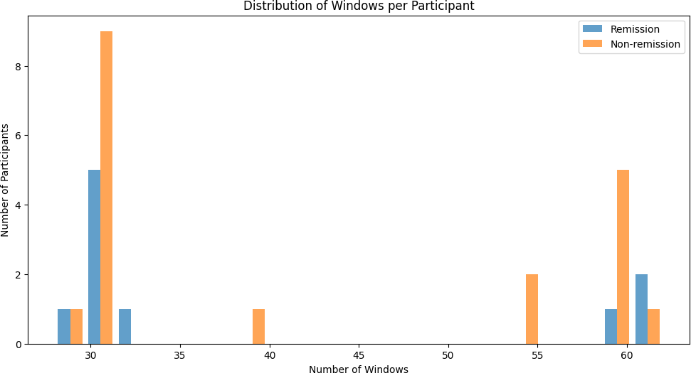
Figure 1: Distribution of Windows per participant
Analysis of the EEG window distributions revealed distinct sampling patterns between remission and non-remission groups, as illustrated in Figure 1. The histogram visualization in the figure demonstrates variability in the number of windows collected per participant, suggesting potential differences in recording duration or data quality between subjects. This variability needs to be considered in subsequent analyses to avoid sampling bias.

Signal Characteristics

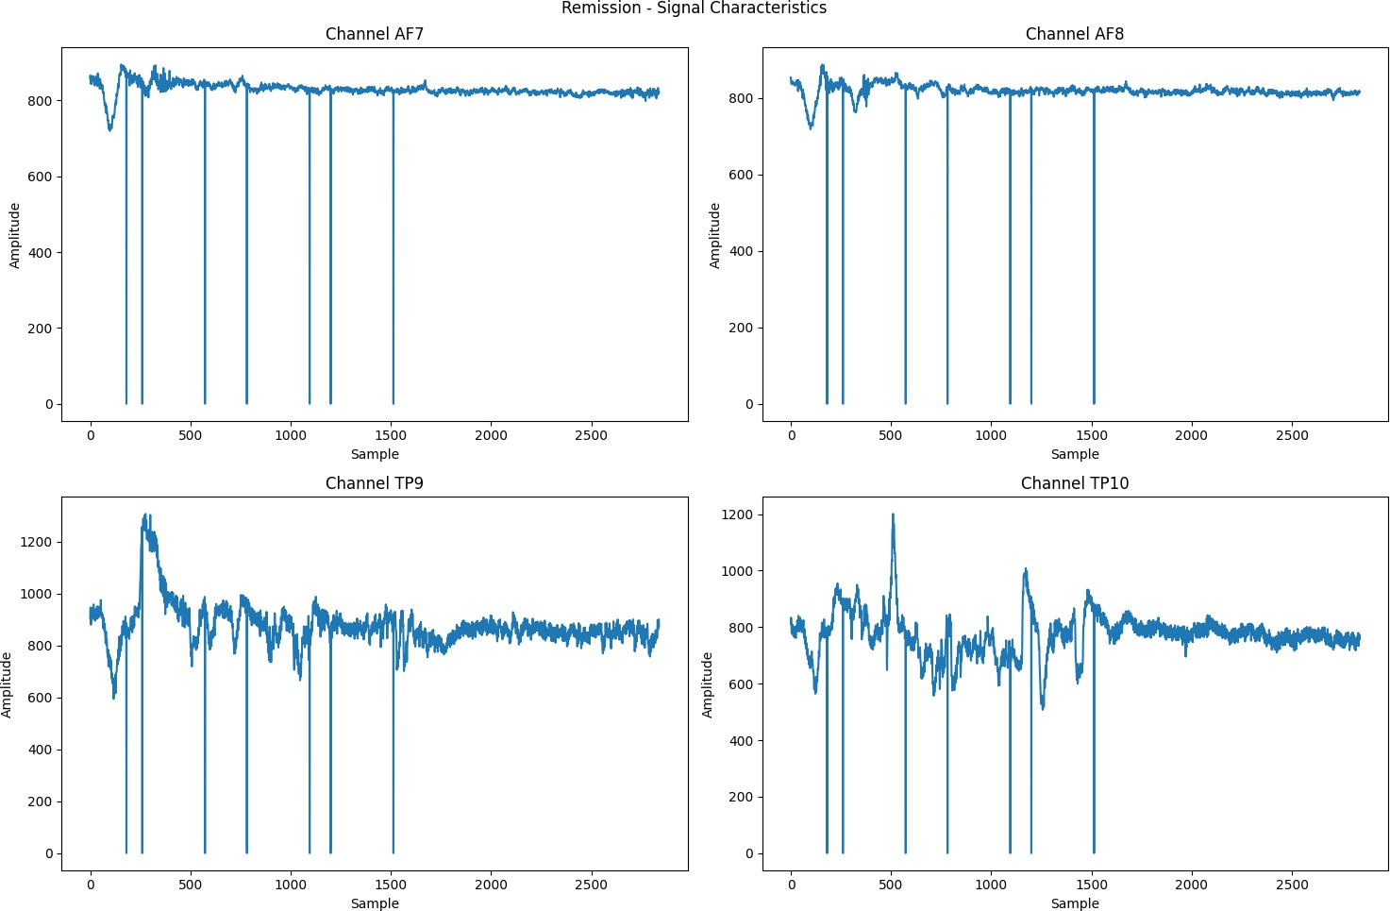
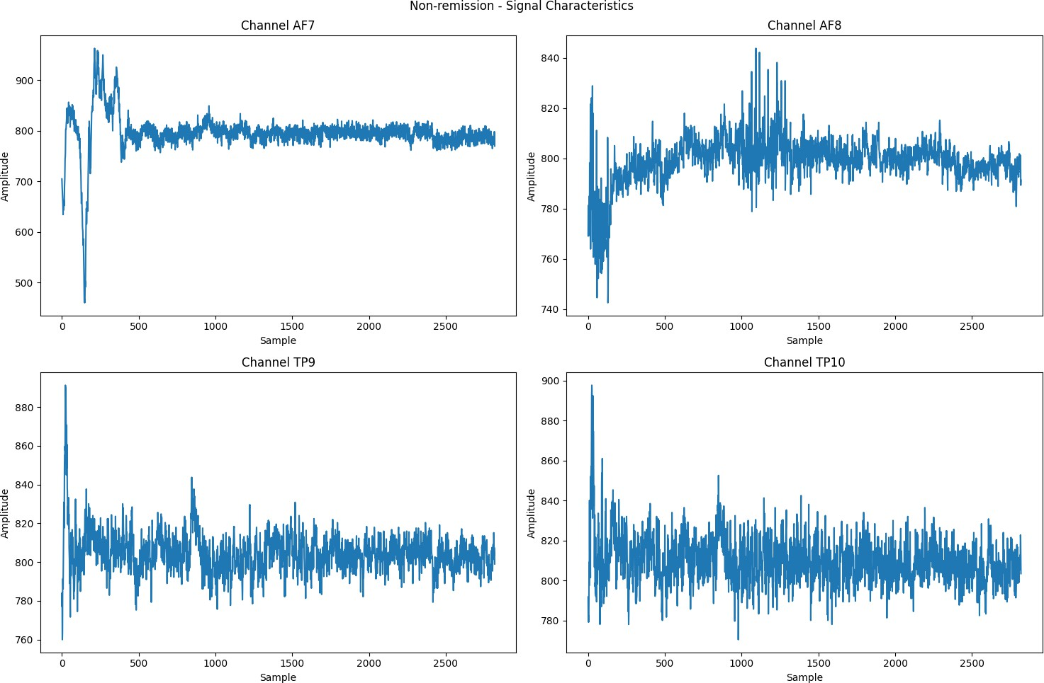

(a) Remission Signal Characterisitics (b) Non Remission Signal Characteristics
Figure 2: Signal Characteristics

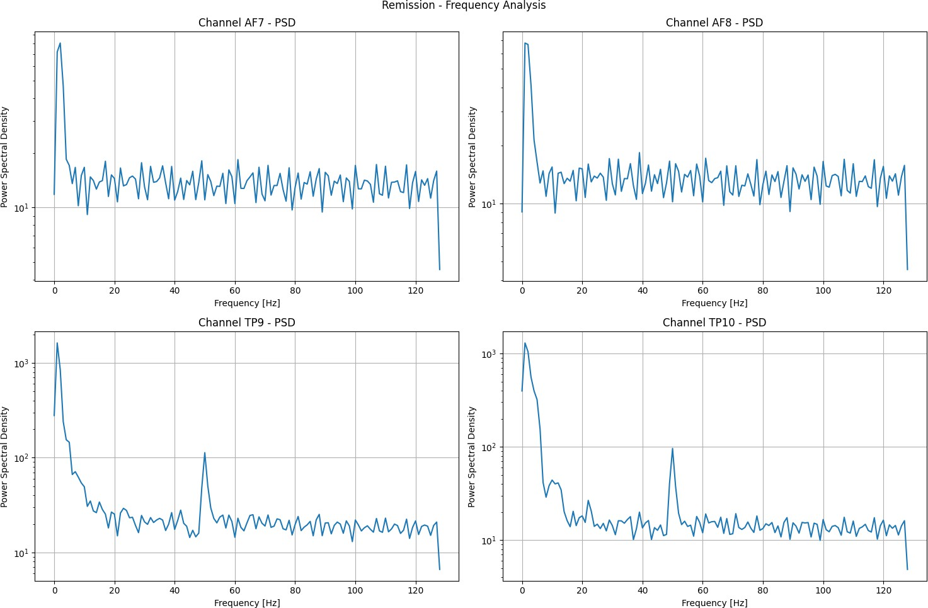
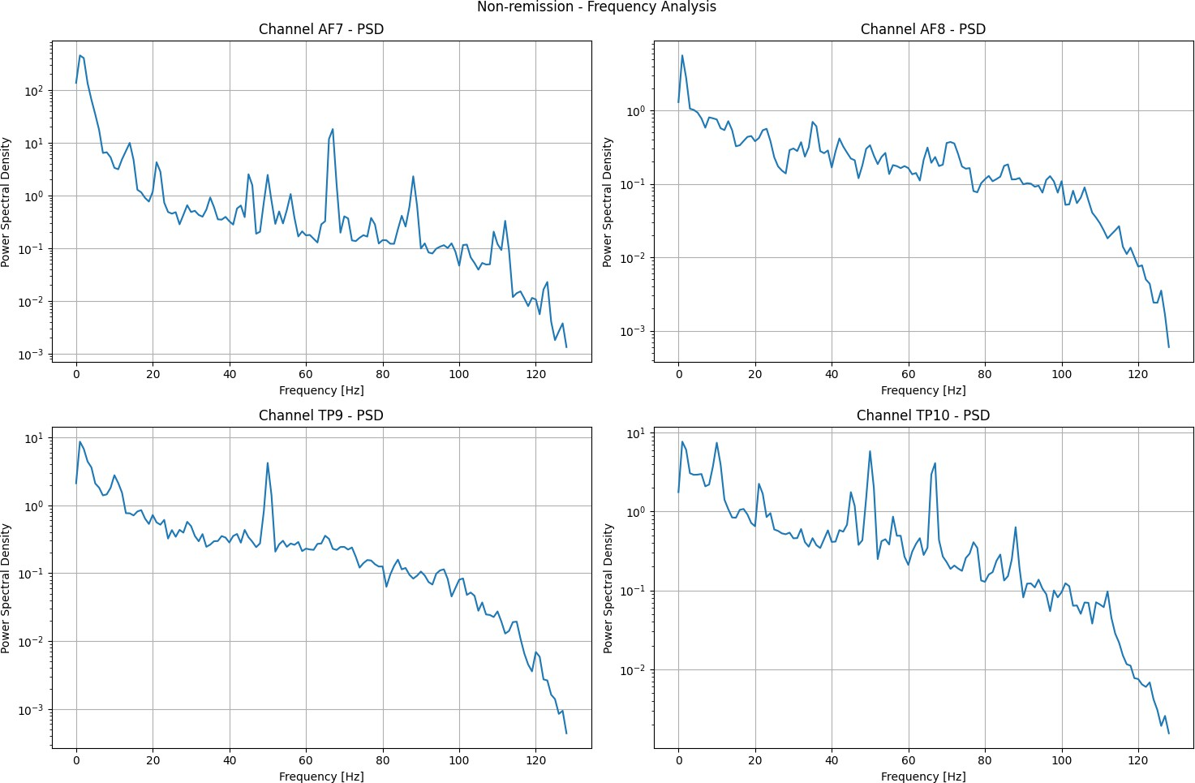

(a) Remission Frequency Analysis (b) Non Remission Frequency Analysis
Figure 3: Frequency Analysis
We can see in Figure 2 and 3 Temporal and spectral analyses were conducted on four key channels: AF7, AF8, TP9, and TP10. The time-domain plots reveal characteristic EEG waveforms with varying amplitudes across channels. Notable differences were observed between anterior (AF7, AF8) and temporal (TP9, TP10) electrode positions.
Power spectral density (PSD) analysis, computed using Welch’s method, demonstrated typical 1/f power distribution characteristic of EEG signals. All channels exhibited prominent activity in lower frequency bands (delta, theta) with decreasing power at higher frequencies. The remission group showed subtle differences in spectral power distribution compared to the non-remission group, particularly in the alpha (8-12 Hz) range.

Channel Correlations
Cross-channel correlation analysis shown in Figures 4a and 4b unveiled intricate patterns of functional connectivity across electrode sites. The correlation heatmaps

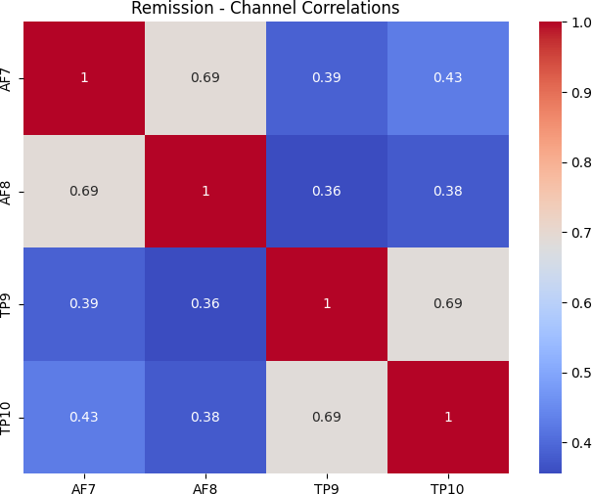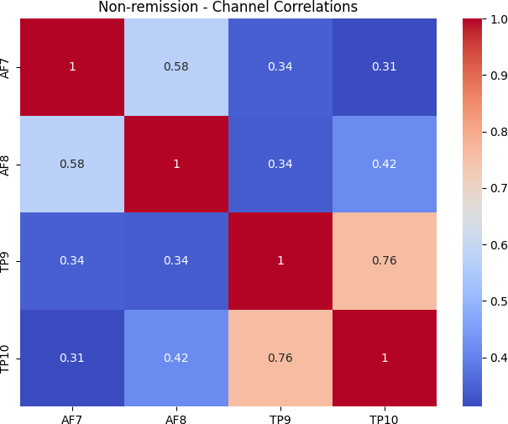

(a) Remission Channel Correlations (b) Non remission channel correlations
Figure 4: Channel Correlations

revealed nuanced relationships between different brain regions, highlighting strong positive correlations particularly between homologous electrode pairs such as AF7-AF8 and TP9-TP10. Additionally, moderate correlations were observed between anterior and temporal electrodes, suggesting complex neural network interactions.
Of particular interest were the distinct correlation patterns that emerged when comparing remission and non-remission groups. These differences in functional connectivity matrices provide compelling insights into potential neurological markers that could distinguish treatment outcomes. The analysis suggests that these correlation patterns might serve as a valuable biomarker for predicting patient response to treatment, offering a promising avenue for more personalized therapeutic approaches.
The comprehensive examination of these neural connectivity patterns demonstrates the sophisticated interplay of brain regions and underscores the potential of advanced neuroimaging techniques in understanding complex neurological processes. By mapping these intricate correlations, researchers can gain deeper insights into brain function and potentially develop more targeted interventions.

Frequency Band Analysis
Detailed analysis of canonical frequency bands (Delta: 0.5-4 Hz, Theta: 4-8 Hz, Alpha: 8-12 Hz, Beta: 12-30 Hz, and Gamma: 30-60 Hz) as shown in Figure 5 revealed several key findings in brain wave patterns.
The power distribution across these frequency bands followed expected physiological patterns, with notable variations observed across different neural channels. Researchers identified significant channel-specific differences in band power, suggesting nuanced neural activity variations. A critical observation was the notable differences in band power distributions between remission and non-remission groups, indicating potential neurological markers for clinical assessment. Particularly intriguing was the higher variability in gamma band power across all channels, which may suggest complex neural processing dynamics. The visual representation through box plots demonstrated that power distributions were generally right-skewed, especially in higher frequency bands.

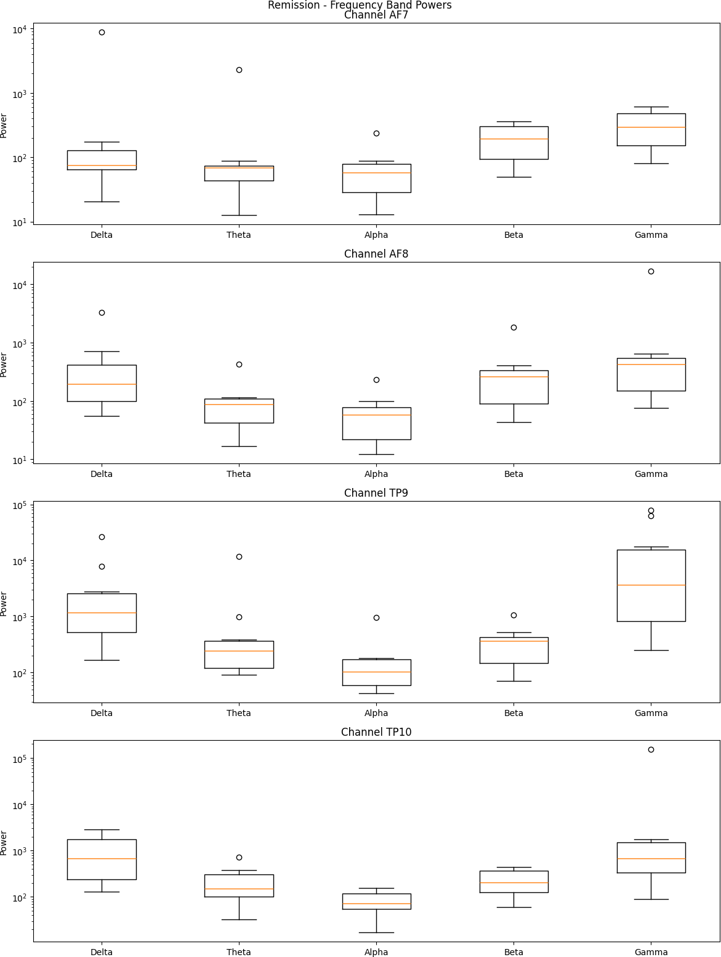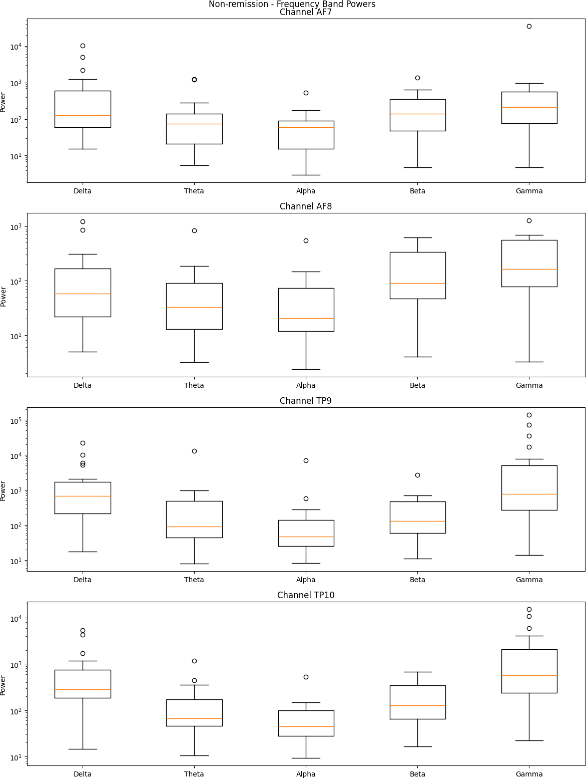

(a) Remission Frequency Band Powers (b) Non Remission Frequency Band Powers
Figure 5: Frequency Band Analysis

This skewness necessitated logarithmic scaling for accurate visualization and statistical analysis, highlighting the complexity of neural signal interpretation. These findings underscore the importance of comprehensive frequency band analysis in understanding neural activity and potential clinical implications.

Statistical Analysis

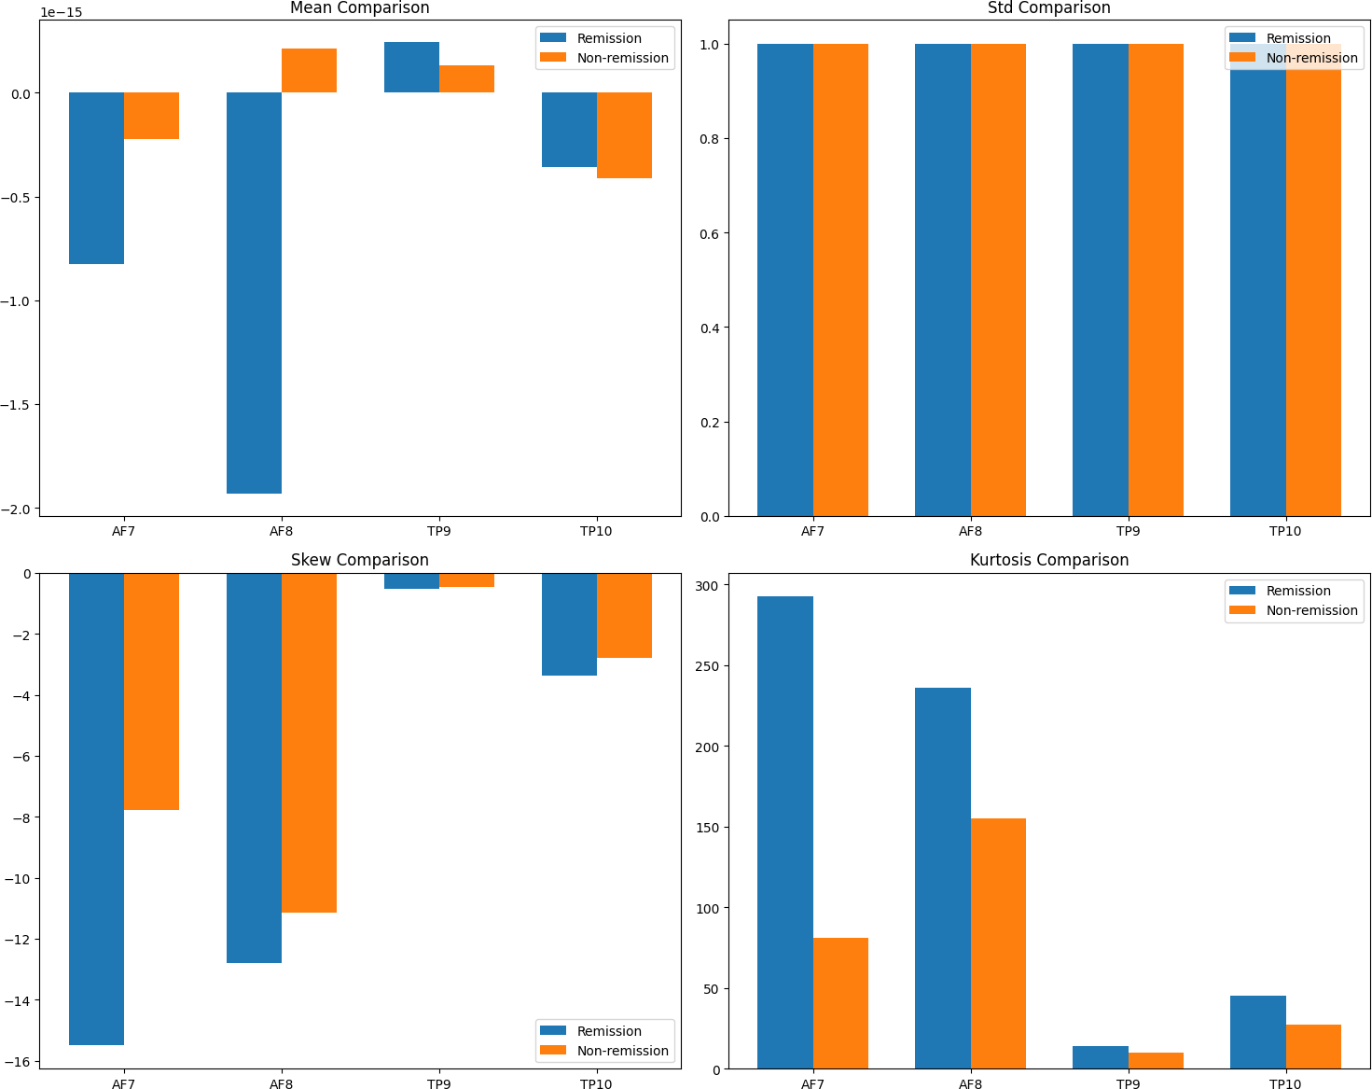

Figure 6: Statistical comparisons between channels
Figure 6 shows the statistical comparison between remission and non-remission groups which revealed several significant differences in signal characteristics. Mann-Whitney U tests were employed to account for potential non-normal distributions in the data. Key findings include:
- Channel-specific differences in signal properties between groups
- Variations in statistical moments (mean, standard deviation, skewness, and kurtosis)
- Differential patterns of signal variability between anterior and temporal electrode sites
The comparative statistics suggest that EEG signal characteristics may have predictive value for treatment outcomes, though further investigation with larger samples would be necessary to confirm these findings.
These results provide a comprehensive characterization of the EEG data structure and highlight potential electrophysiological markers that distinguish between remission and non-remission groups. The observed differences in spectral power, cross-channel

correlations, and statistical properties warrant further investigation in the context of treatment outcome prediction.

Updated Methodology

EEG Signal Processing Pipeline for Depression Remission Prediction
In this work, we present a comprehensive machine learning pipeline for analyzing electroencephalogram (EEG) signals to predict depression remission. Our methodology integrates multiple advanced signal processing techniques, feature extraction algorithms, and classification strategies to robustly capture the relevant neural dynamics. We detail the stages of data acquisition, preprocessing (including upsampling, filtering, and downsampling), window slicing, extensive feature extraction (spectral, temporal, complexity, and connectivity measures), and both window-level and patient-level model training. All experiments and metrics are logged systematically using MLflow, enabling reproducibility and rigorous evaluation. The pipeline’s modular design allows for scalability and adaptability to various EEG data characteristics and classification challenges.
Combining diverse signal processing methods with robust machine learning models is challenging due to the complex, non-stationary, and high-dimensional nature of EEG data. Our pipeline addresses these challenges by:
- Standardizing data loading.
- Implementing multiple stages of preprocessing to enhance signal quality.
- Applying window slicing to segment continuous recordings.
- Extracting a rich set of features that capture time-domain statistics, frequency- domain power spectra, nonlinear dynamics, and inter-channel relationships.
- Training and validating both window-level classifiers and patient-level models, thereby accounting for intra- and inter-patient variability.

This paper describes our methodology in detail, highlighting the design choices and technical implementations that together form an end-to-end EEG analysis pipeline.

Data Loading
Our pipeline begins with data acquisition from MATLAB files containing separated EEG recordings for remission and non-remission groups. The DataLoader module is tasked with:
- Reading MATLAB Files: MATLAB .mat files are loaded.
- Group-specific Processing: Data is parsed with unique keys (e.g., EEG windows Remission and EEG windows Non remission) for each distinct patient group.

- Channel Extraction: Using configuration parameters, signals from specific channels (e.g., ‘af7’, ‘af8’, ‘tp9’, ‘tp10’) are extracted along with participant metadata.
- Data Structuring: The processed data is arranged into a Pandas DataFrame for subsequent window slicing and feature extraction.

This modular design enables the pipeline to handle heterogeneous data sources with minimal additional configuration.

Signal Preprocessing
Preprocessing is essential for ensuring signal quality and reducing noise. Our pipeline incorporates several key steps:

Upsampling
Prior to filtering, the EEG signals may be upsampled to a higher resolution using techniques such as linear interpolation (as defined in the upsampler module). This ensures that the subsequent filtering and feature extraction steps operate on data with sufficient temporal resolution.

Filtering
To remove high-frequency noise and potential artifacts, a Butterworth low-pass filter is applied:
- Filter Design: The filter is designed based on the specified cutoff frequency and filter order. The normalized cutoff frequency is computed relative to the nyquist frequency.
- Implementation: The EEGFilter class implements the filtering procedure using standard signal processing libraries and logs filter design parameters using MLflow. This design facilitates the reproduction of filter characteristics (e.g., cutoff frequency, filter order).

Downsampling
After filtering, the signals are downsampled to align all data segments to a uniform size. The EEGDownsampler class utilizes decimation methods (with anti-aliasing filters) for efficient reduction in signal sampling rate. Downsampling parameters are configurable, ensuring flexibility in terms of resolution versus computational efficiency trade-offs.

Window Slicing
EEG signals are inherently continuous; therefore, a segmentation process is adopted to break the continuous recordings into fixed-length windows. The EEGWindowSlicer module performs the following:

- Segmentation Logic: Using parameters such as window duration (e.g., 10 seconds), overlap duration, and sampling rate, the continuous signal is segmented into discrete, non-overlapping (or overlapping) windows.
- Metadata Preservation: Each window preserves relevant metadata such as participant identifiers, group labels, and window indices. This is critical for later aggregation during patient-level modeling.
- Parallel Processing: The slicing process is optimized using parallel processing (via Python’s ThreadPoolExecutor), facilitating efficient handling of large datasets.

The output of this step is a structured DataFrame where each row represents an individualized window ready for feature extraction.

Feature Extraction
Feature extraction is the core step of the pipeline, converting raw windowed EEG signals into quantitative descriptors that capture signal characteristics across multiple domains:

Spectral Features
Power Spectral Density (PSD): Utilizing Welch’s method, PSD is computed for each channel.

Frequency Band Analysis:
- Absolute power within standard EEG frequency bands (delta, theta, alpha, beta, gamma)
- Relative band power (normalized by total power)
- Frequency-weighted power (center of gravity of the power spectrum)

Hemispheric Asymmetry:
      - Frontal Asymmetry (AF7/AF8):
        - Log-transformed asymmetry index: log(right/left)
        - Normalized asymmetry ratio: (right-left)/(right+left)

Temporal Asymmetry (TP9/TP10):
        - Log-transformed asymmetry index: log(right/left)
        - Normalized asymmetry ratio: (right-left)/(right+left)
These measures provide insights into both the dominant neural oscillations and hemispheric balance associated with different cognitive states.

Temporal (Statistical) Features
For each window, time-domain statistical features are computed, including:
- Mean, standard deviation, variance
- Skewness and kurtosis
- Root mean square (RMS)
- Peak-to-peak amplitude, zero crossings, and mean absolute deviation
- Hjorth Parameters: Activity, mobility, and complexity measures are calculated to assess signal variability and dynamic complexity.

Entropy and Complexity Features
The non-linear aspects of EEG signals are quantified through:
- Sample Entropy: A measure of signal irregularity.
- Spectral Entropy: Derived from the normalized power spectral density.
- Complexity Measures: Including Higuchi Fractal Dimension (HFD), correlation dimension, Hurst exponent, Lyapunov exponent, and detrended fluctuation analysis (DFA). These measures leverage the nolds library to capture inherent signal complexities.

Connectivity Features
Inter-channel relationships are explored by computing:
- Cross-correlation coefficients between pairs of channels
- Asymmetry measures between homologous channels
- Band-specific connectivity patterns
These features offer insights into functional connectivity patterns and hemispheric interactions during different mental states.
The EEGFeatureExtractor class encapsulates these computations, ensuring:
- Robust error handling
- Signal validation (checking for NaN and infinite values)
- Parallel processing for optimal runtime
- Optional saving of interim results
- Comprehensive feature documentation and statistics logging via MLflow
This expanded feature set, particularly the addition of asymmetry measures and frequency-weighted analysis, provides a more complete characterization of the EEG signals, potentially improving the model’s ability to distinguish between remission and non-remission states.

Model Training and Evaluation
Two levels of classification models are built to capture both local signal dynamics and holistic patient-level behavior.

Window-Level Classification
- Feature Input: Each window’s extracted features serve as inputs for the classifier.
- Cross-Validation: Leave-One-Group-Out (LOGO) cross-validation is implemented to ensure that windows from the same participant do not appear in both training and testing datasets simultaneously, thereby reducing bias.
- Model Implementation: The WindowLevelTrainer class leverages standard classifiers (e.g., Random Forest) and logs detailed performance metrics during each fold. Window-level predictions are aggregated to inform patient-level decision-making.

Patient-Level Classification
- Aggregation: Windows for each participant are aggregated using statistical summaries (mean, standard deviation, min, max, and median) to create patient-level feature vectors.
- Training: A separate patient-level classifier is trained based on these aggregated features using the PatientLevelTrainer class.
- Evaluation: Cross-validation again ensures that data leakage is minimized. Metrics such as accuracy, precision, recall, F1 score, and ROC AUC are computed and logged.

Experiment Logging and Visualization
- MLflow Integration: Throughout the pipeline, MLflow is utilized to log configuration parameters, training metrics, and intermediate artifacts (e.g., feature importance reports).
- Metrics Calculation: The MetricsCalculator module computes detailed metrics, including cross-validation statistics and feature importance rankings.
- Visualization: Custom visualization routines (in the ResultVisualizer class) create interactive plots and static visualizations (using Plotly, Seaborn, and Matplotlib) to aid in interpreting feature importance and model performance.

Experimental Setup and Configuration
The pipeline’s behavior is governed by a central YAML configuration file. Key parameters include:
- Paths: Locations for raw data, interim processed files, and final feature outputs.

- Data Loader Settings: Specification of channels, data validation flags, and MATLAB file keys.
- Preprocessing Parameters: Upsampling factors, filtering parameters (e.g., filter type, order, cutoff frequency), downsampling parameters.
- Window Slicing Specifications: Window duration, overlap, and minimum window count per participant.
- Feature Extraction: Frequency bands and lists of statistical, entropy, and complexity features.
- MLflow Settings: Experiment names, run names, and tracking URIs for rigorous experiment logging.

By adjusting these parameters, the pipeline can be adapted to new datasets or research objectives with minimal code modifications.
Our methodology spans the entire process from robust data loading and preprocessing to feature extraction and dual-level model training. The comprehensive extraction of spectral, temporal, complexity, and connectivity features allows the models to capture nuanced neural patterns associated with mental health states. The incorporation of rigorous cross-validation, experiment logging via MLflow, and extensive visualization promotes transparency and reproducibility. Future work may extend this approach by integrating additional signal processing methods, exploring deep learning architectures, and applying the pipeline to larger and more diverse patient datasets.
This work demonstrates how a modular, configurable pipeline can effectively translate raw EEG signals into clinically relevant predictions, providing a solid foundation for future research in EEG-based diagnostics and personalized medicine.

Results

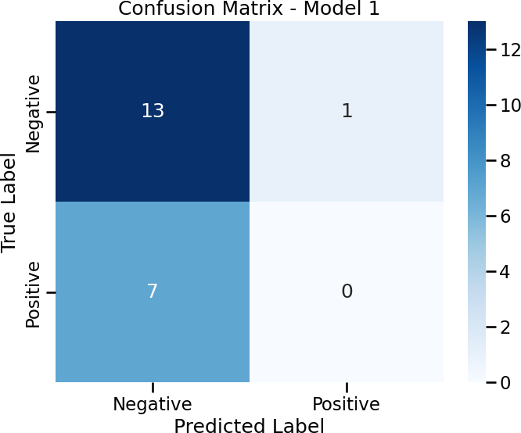
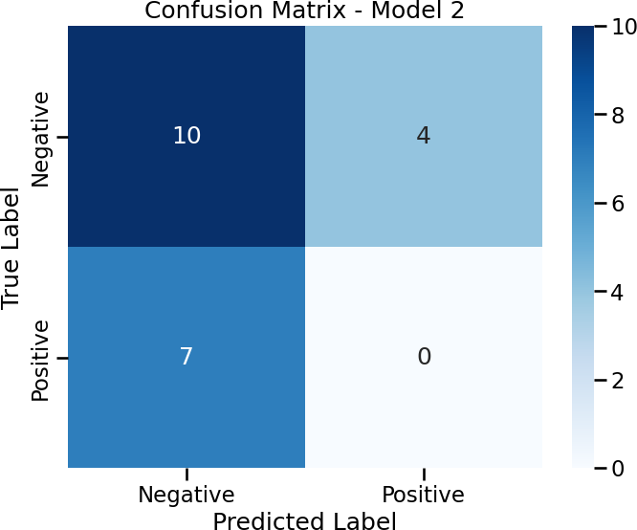

(a) Confusion Matrix - Model 1 (b) Confusion Matrix - Model 2

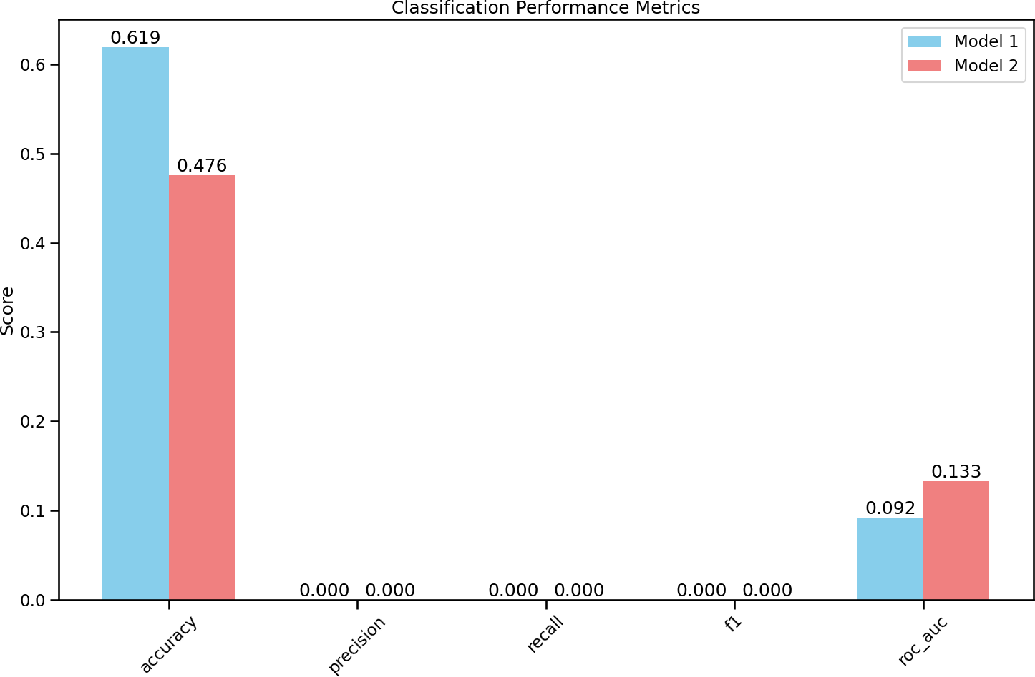
Figure 8: Classification Performance Metrics

A comparison of classification performance between models utilizing different temporal window lengths has revealed notable differences in predictive capabilities for EEG-based remission classification. Looking at Figure 8 Model 1, which employs 10-second windows, we achieved an overall accuracy of 61.9%, whereas Model 2, using 2-second windows, performed worse with an accuracy of 47.6%. The ROC-AUC scores for both models were low, with Model 1 at 0.092 and Model 2 at 0.133, indicating poor discrimination between classes.
Both models demonstrated concerning patterns in precision, recall, and F1 scores, all registering at 0.0. This reflects a complete failure to identify positive cases of remission in either window length configuration. Analysis of the confusion matrices shown in Figures 7a and 7b further supports this finding. Model 1 correctly identified 13 true negatives and had 1 false positive, but failed to detect any true positives, leading to 7 false negatives. Model 2 showed slightly poorer specificity, with 10 true negatives, 4 false positives, and the same number of false negatives and true positives as Model 1. The results indicate a strong bias toward negative predictions and a complete lack of sensitivity in detecting remission cases.
These findings suggest that neither window length configuration provides sufficient discriminative power for reliable remission prediction. The 2-second window performed worse overall, potentially due to inadequate temporal resolution. However, the total absence of true positive predictions in both models indicates a more fundamental limitation in the current approach, beyond just window length selection. Further refinement is necessary, particularly in feature extraction, class imbalance mitigation, and potential alternative temporal configurations. Incorporating additional EEG characteristics or clinical variables may also enhance classification performance.

Current Challenges and Proposed Resolutions
Despite incorporating a diverse set of spectral, temporal, entropy, and connectivity features, model discrimination remains poor, as evidenced by ROC-AUC values ranging from 0.092 to 0.133. This suggests issues with feature interaction or relevance. To address this, hierarchical feature selection will be implemented, grouping features by domain and evaluating their contributions independently. LASSO or elastic net regularization will help identify the most predictive features, while an in-depth analysis will explore the relationship between hemispheric asymmetry measures, band powers, entropy values, and connectivity patterns.
The complete absence of true positives suggests a significant class imbalance issue. Models currently show a bias toward negative predictions, with zero recall for the remission class. To counteract this, class weighting strategies will be introduced, along with Synthetic Minority Over-sampling Technique (SMOTE) or other resampling techniques. Collecting additional data for the minority class and implementing cost-sensitive learning approaches may further improve balance in classification outcomes.
Temporal window selection has also proven to be a factor affecting performance, with shorter 2-second windows performing worse than 10-second segments. To optimize this aspect, intermediate window lengths (e.g., 4s, 6s, 8s) will be tested, and multi-scale analysis will be explored. Using overlapping windows may increase data utilization, while dynamic window sizing based on EEG signal characteristics may yield more robust results.
The classification approach itself may require adaptation. Current models may not be capturing the complex patterns necessary for accurate remission prediction. Implementing ensemble methods, and exploring other architectures specifically designed for EEG analysis.
Signal quality remains another area of concern. Poor model performance may be attributed to underlying issues in EEG preprocessing. To address this, more robust artifact removal procedures will be implemented, and additional normalization techniques will be tested. Improved preprocessing, including independent component analysis (ICA), will be explored to ensure high-quality input signals. Pre-extraction validation steps will also be incorporated to ensure only high-fidelity signals contribute to feature computation.

References
Abbasi, B. & Goldenholz, D. M. (2019), ‘Machine learning applications in epilepsy’, Epilepsia 60(10), 2037–2047.
Al-Kaysi, A. M., Al-Ani, A., Loo, C. K., Breakspear, M. & Boonstra, T. W. (2016), Predicting brain stimulation treatment outcomes of depressed patients through the classification of eeg oscillations, IEEE, pp. 5266–5269.
Al-Kaysi, A. M., Al-Ani, A., Loo, C. K., Powell, T. Y., Martin, D. M., Breakspear, M. & Boonstra, T. W. (2017), ‘Predicting tdcs treatment outcomes of patients with major depressive disorder using automated eeg classification’, Journal of Affective Disorders 208, 597–603.

Alzahy, A., Elgammal, M., Mohammed, H. & Mostafa, H. (2019), ‘Optimal eeg window size for neural seizure detection’, 2019 8th International Conference on Modern Circuits and Systems Technologies (MOCAST) .
Brunoni, A. R., Moffa, A. H., Fregni, F., Palm, U., Padberg, F., Blumberger, D. M., Daskalakis, Z. J., Bennabi, D., Haffen, E., Alonzo, A. & Loo, C. K. (2016), ‘Transcranial direct current stimulation for acute major depressive episodes: Meta-analysis of individual patient data’, British Journal of Psychiatry 208(6), 522–531.
Cao, Y., Li, W., Shen, J., Malison, R. T., Zhang, Y. & Luo, X. (2013), ‘Health-related quality of life and symptom severity in chinese patients with major depressive disorder’, Asia-Pacific Psychiatry 5(4), 276–283.
Casson, A., Yates, D., Smith, S., Duncan, J. & Rodriguez-Villegas, E. (2010), ‘Wearable electroencephalography’, IEEE Engineering in Medicine and Biology Magazine 29(3), 44–56.
Chiarion, G., Sparacino, L., Antonacci, Y., Faes, L. & Mesin, L. (2023), ‘Connectivity analysis in eeg data: A tutorial review of the state of the art and emerging trends’, Bioengineering .
Dagnino, P. C., Braboszcz, C., Kroupi, E., Splittgerber, M., Brauer, H., Dempfle, A., Breitling-Ziegler, C., Prehn-Kristensen, A., Krauel, K., Siniatchkin, M., Moliadze, V. & Soria-Frisch, A. (2023), ‘Stratification of responses to tdcs intervention in a healthy pediatric population based on resting-state eeg profiles’, Scientific Reports 13(1).
Ebrahimzadeh, E., Fayaz, F., Rajabion, L., Seraji, M., Aflaki, F., Hammoud, A., Taghizadeh, Z., Asgarinejad, M. & Soltanian-Zadeh, H. (2023), ‘Machine learning approaches and non-linear processing of extracted components in frontal region to predict rtms treatment response in major depressive disorder’, Frontiers in Systems Neuroscience 17.
Ghiasi, S., Dell’Acqua, C., Benvenuti, S. M., Scilingo, E., Gentili, C., Valenza, G. & Greco, A. (2021), Classifying subclinical depression using eeg spectral and connectivity measures, IEEE, pp. 2050–2053.
Ip, C.-T., Ganz, M., Dam, V. H., Ozenne, B., Ru¨esch, A., K¨ohler-Forsberg, K., Jørgensen,
M. B., Frokjaer, V. G., Søgaard, B., Christensen, S. R., Knudsen, G. M. & Olbrich,
S. (2021), ‘Neuropharm study: Eeg wakefulness regulation as a biomarker in mdd’, Journal of Psychiatric Research 141, 57–65.
Jaworska, N., de la Salle, S., Ibrahim, M.-H., Blier, P. & Knott, V. (2019), ‘Leveraging machine learning approaches for predicting antidepressant treatment response using electroencephalography (eeg) and clinical data’, Frontiers in Psychiatry 9.
Jiang, X., Bian, G.-B. & Tian, Z. (2019), ‘Removal of artifacts from eeg signals: A review’, Sensors 19(5), 987.
Kelley, M. E., Choi, K. S., Rajendra, J. K., Craighead, W. E., Rakofsky, J. J., Dunlop, B. W. & Mayberg, H. S. (2021), ‘Establishing evidence for clinical utility of a neuroimaging biomarker in major depressive disorder: Prospective testing and implementation challenges’, Biological Psychiatry 90(4), 236–242.

Kennedy, S. H. (2008), ‘Core symptoms of major depressive disorder: relevance to diagnosis and treatment’, Dialogues in Clinical Neuroscience 10(3), 271–277.
Khadidos, A. O., Alyoubi, K. H., Mahato, S., Khadidos, A. O. & Mohanty, S. N. (2023), ‘Machine learning and electroencephalogram signal based diagnosis of depression’, Neuroscience Letters 809, 137313.
Lee, T., Nam, S. & Hyun, D. J. (2023), ‘Adaptive window method based on fbcca for optimal ssvep recognition’, IEEE Transactions on Neural Systems and Rehabilitation Engineering .
Li, P., Karmakar, C., Yearwood, J., Venkatesh, S., Palaniswami, M. & Liu, C. (2018), ‘Detection of epileptic seizure based on entropy analysis of short-term eeg’, PLOS ONE 13(3), e0193691.
Li, Q. S., Galbraith, D., Morrison, R. L., Trivedi, M. H. & Drevets, W. C. (2022), ‘Circulating microrna associated with future relapse status in major depressive disorder’, Frontiers in Psychiatry 13.
Libbrecht, M. W. & Noble, W. S. (2015), ‘Machine learning applications in genetics and genomics’, Nature Reviews Genetics 16(6), 321–332.
Loo, C. K., Sachdev, P., Martin, D., Pigot, M., Alonzo, A., Malhi, G. S., Lagopoulos, J. & Mitchell, P. (2009), ‘A double-blind, sham-controlled trial of transcranial direct current stimulation for the treatment of depression’, The International Journal of Neuropsychopharmacology 13(01), 61.
Louridas, P. & Ebert, C. (2016), ‘Machine learning’, IEEE Software 33(5), 110–115.
Mahato, S., Goyal, N., Ram, D. & Paul, S. (2020), ‘Detection of depression and scaling of severity using six channel eeg data’, Journal of Medical Systems 44(7).
Maxwell, A. E., Warner, T. A. & Fang, F. (2018), ‘Implementation of machine-learning classification in remote sensing: an applied review’, International Journal of Remote Sensing 39(9), 2784–2817.
Miranda, P., Cox, C. D., Alexander, M., Danev, S. & Lakey, J. R. (2019), ‘Overview of current diagnostic, prognostic, and therapeutic use of eeg and eeg-based markers of cognition, mental, and brain health’, Integrative Molecular Medicine 6(5).
Murali, S. & Kulish, V. V. (2007), ‘Modeling of evoked potentials of electroencephalograms: An overview’, Digital Signal Processing 17(3), 665–674.
Mutz, J., Vipulananthan, V., Carter, B., Hurlemann, R., Fu, C. H. Y. & Young, A. H. (2019), ‘Comparative efficacy and acceptability of non-surgical brain stimulation for the acute treatment of major depressive episodes in adults: systematic review and network meta-analysis’, BMJ p. l1079.
Ouyang, D., Yuan, Y., Li, G. & Guo, Z. (2022), ‘The effect of time window length on eeg-based emotion recognition’, Sensors 22(13), 4939.

PUTHANKATTIL, S. D. & JOSEPH, P. K. (2012), ‘Classification of eeg signals in normal and depression conditions by ann using rwe and signal entropy’, Journal of Mechanics in Medicine and Biology 12(04), 1240019.
Serretti, A. (2022), ‘Clinical utility of fluid biomarker in depressive disorder’, Clinical Psychopharmacology and Neuroscience 20(4), 585–591.
Shikha, S., Sethia, D. & Indu, S. (2024), ‘Investigating the effect of sliding window length for eeg-based anxiety classification’, 2024 Asia Pacific Conference on Innovation in Technology (APCIT) .
Siuly, S., Li, Y. & Zhang, Y. (2016), Electroencephalogram (eeg) and its background, Springer International Publishing, pp. 3–21.
Wang, B., Kang, Y., Huo, D., Chen, D., Song, W. & Zhang, F. (2023), ‘Depression signal correlation identification from different eeg channels based on cnn feature extraction’, Psychiatry Research: Neuroimaging 328, 111582.
Woodham, R. D., Selvaraj, S., Lajmi, N., Hobday, H., Sheehan, G., Ghazi-Noori, A.- R., Lagerberg, P. J., Rizvi, M., Kwon, S. S., Orhii, P., Maislin, D., Hernandez, L., Machado-Vieira, R., Soares, J. C., Young, A. H. & Fu, C. H. (2023), ‘Home-based transcranial direct current stimulation rct in major depression’.
Zandvakili, A., Philip, N. S., Jones, S. R., Tyrka, A. R., Greenberg, B. D. & Carpenter,
L. L. (2019), ‘Use of machine learning in predicting clinical response to transcranial magnetic stimulation in comorbid posttraumatic stress disorder and major depression: A resting state electroencephalography study’, Journal of Affective Disorders 252, 47– 54.
Zhao, S., Ng, S.-C., Khoo, S. & Chi, A. (2022), ‘Temporal and spatial dynamics of eeg features in female college students with subclinical depression’, International Journal of Environmental Research and Public Health 19(3), 1778.

